NAME:G.KISHORE BALAJI

DEPARTMENT:ECE

FINAL ASSIGNMENT

1. https://www.facebook.com/profile.php?id=61550069170454&mibextid=ZbWKwL



·"" 'Swit Z

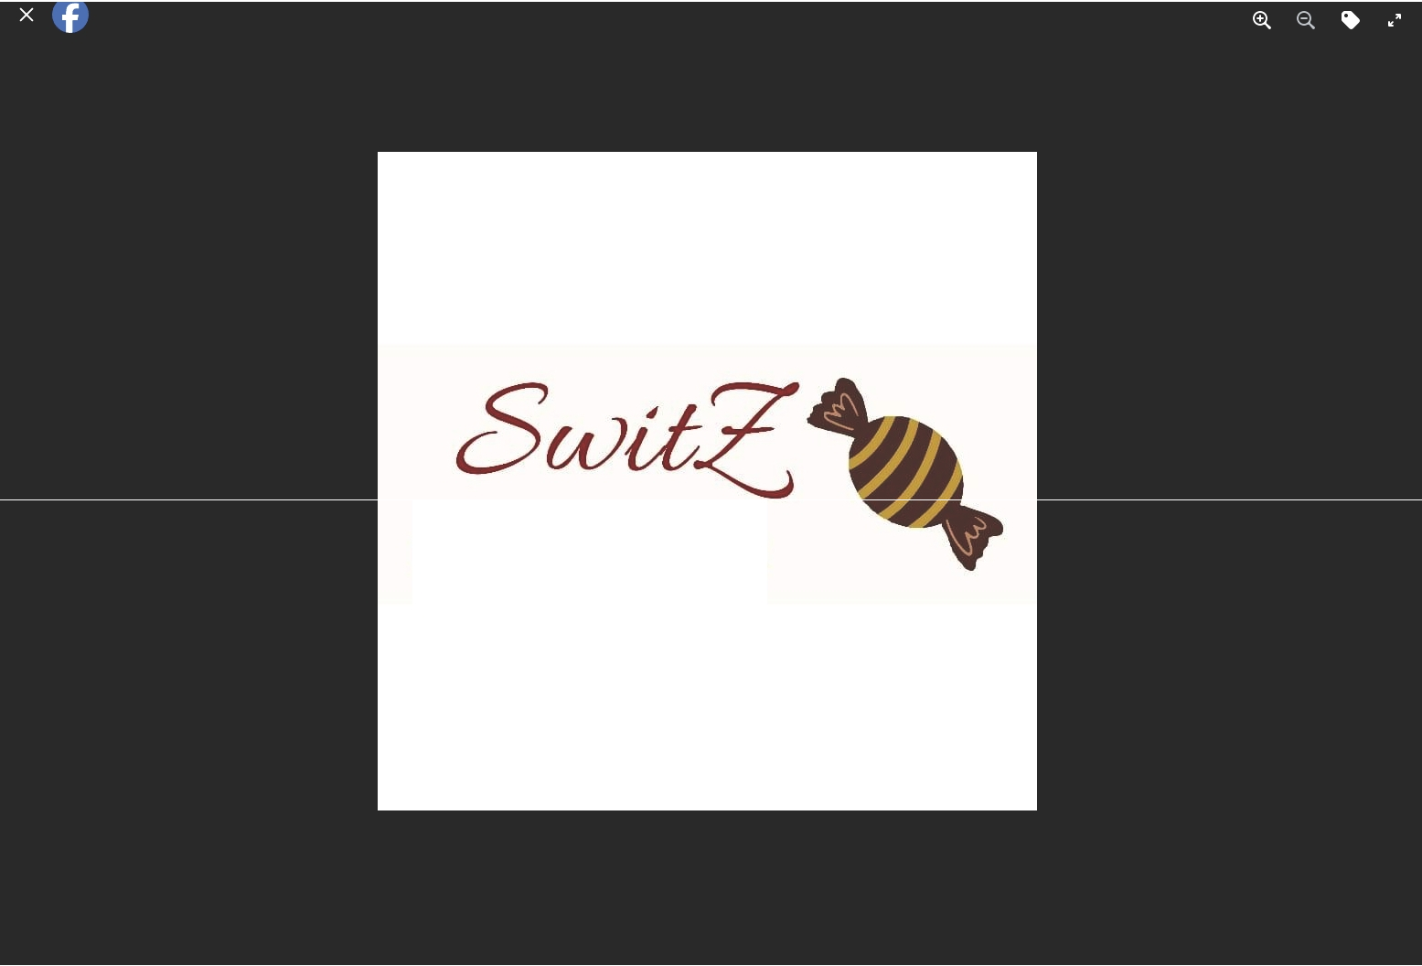

August 19 -

Edit

**Feel it...Fall for it**

rb Like Q Comment Share

, **Write a comment...**



2. https://starchocs.blogspot.com/2023/08/chocorealm-exploring-world-of-artisanal.html



/ - "' ,.,. .m-.TT - Major Heading -

& 0 Preview



ChocoRealm:Exploring the World of Artisanal Chocolate Production



c-:> 1!!1- 1111- © -- !] ·- ·- "

Post settings "' Labels

Star Chocs - Sweet Drugs!!

Introduction

Separate labels by commas No matching suggest ions

In the realm of confectionery delights,the-re's a special place for " ," a term that celebrates the art of crafting exquisite chocolate treats. These artisanal chocolate manufacturers infuse their creations with passion, innovation, and a commitment to quality that eleYates the humble cocoa

bean to new heights of deliciousness_ Join us as we embark on a tantalizing journey into the world of starchocs, \;i.•here creatiYity knows no bounds and every aste of pure enchantment.



### STAR CHOCS

FEEL IT,FALL FOR IT

Published on 8/26/23 12:00AM

Crafting :The i\lagic of Artisanal Chocolate

Starchocs, a term that combines "arti.sanal" and "chocolate,"

captures the essence of the meticulous craftsmanship that goes into each creation. These manufacturers approach chocolate-making as an art form, prioritizing quality oYer quantity. Let's uncover the steps that transform simple ingredients intothese delectable treasures:

I.Sourcing Premium Ingredients: Starchoc artisans are meticulous about sourcing high-quality cocoa beans, often from specific regions to istinctiYe flayor profiles. These beans are meticulously sorted and roasted toperfection.

1. Handcrafting with Care: Artisanal manufacturers often use traditional techniques and hands-on processes to ensure every batch is a masterpiece. They may hand-sort beans, grind them manually,and meticulously oversee e\·ery step to maintain quality.
2. Innovative Flavors: makers are known for their im·entive fla\·ors. They explore a diverse range of ingredients, from exotic spices to locally sourced fruits, to create combinations that titillate the taste buds and surprise the senses.
3. Texture and Design:Texture plays a significant role in the experience. Artisans skillfully balance the smoothness of chocolate with the crunchiness of nuts or the chewiness of caramel. The final designs are often intricate, sho\¥casing the creatiYity and attention to detail.
4. Small Batches:Unlike mass-produced chocolates, are often crafted in small batches. This allO\vs artisans to maintain a higher level of control over the process, resulting in consistent quality and unique flayor nuances.

Diverse Delights from Around the Globe

are a worldwide phenomenon, vvith each region contributing its cultural flayers and techniques tothe craft. From European chocolatiers\vith their emphasis on tradition and sophistication

v Permalink

v Location

v Options

Diverse Delights from Around the Globe

are a worldwide phenomenon,\vith each region contributing itscultural flayors and techniques to the craft. From European chocolatiers \Vi.th their emphasis on tradition and sophistication to South American artisans who embrace the bold flayers of local ingre.die-nts. the world of starchocs is a vibrant tapestry of tastes. *wvvvvvvvv*

Celebrating Creativity and Community

\Vhat sets starchocs apart isthe strong emphasis on creativity and community.Many artisans collaborat al producers, creating a sustainable ecosystem that benefits everyone involved. Moreover, makers often engage inexperimentation, pushing boundaries tocreate new taste sensations that defy convention.

A Sweet Conclusion

are more than just chocolates:they're an embodiment of passion, creativity, and the unyielding pursuit of excellence_ \Vith each piece, artisans tell a story of their dedication to their craft and their desire to offer moments of pure joy to chocolate enthusiasts worldvvi.de. So, the next time you indulge in a piece of ·savor notjust the flavors but the artistry that transforms cocoa beans into edible masterpieces.

3. https://starchocs.blogspot.com/2023/09/variety-of-chocalates-bloody-sweet.html

.. 0

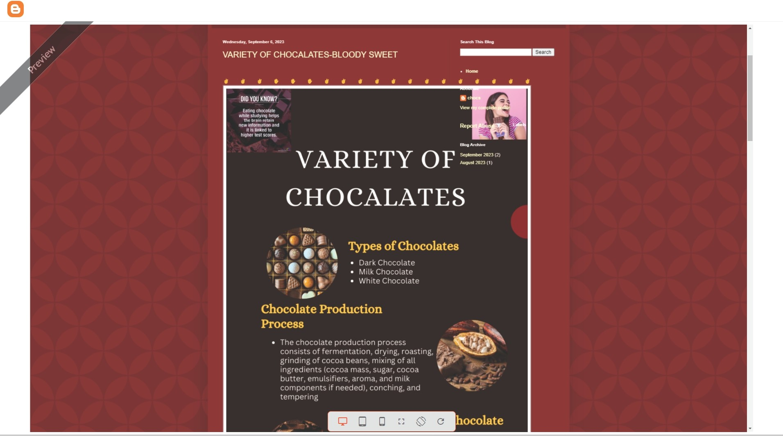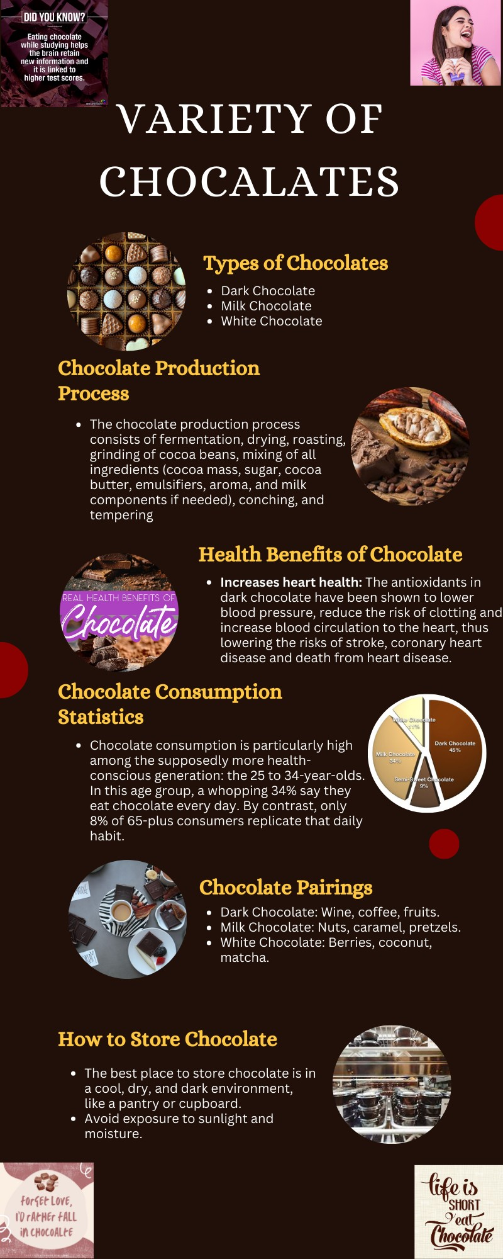

4. https://starchocs.blogspot.com/2023/09/email-newsletter-thank-you-please-visit.html

•

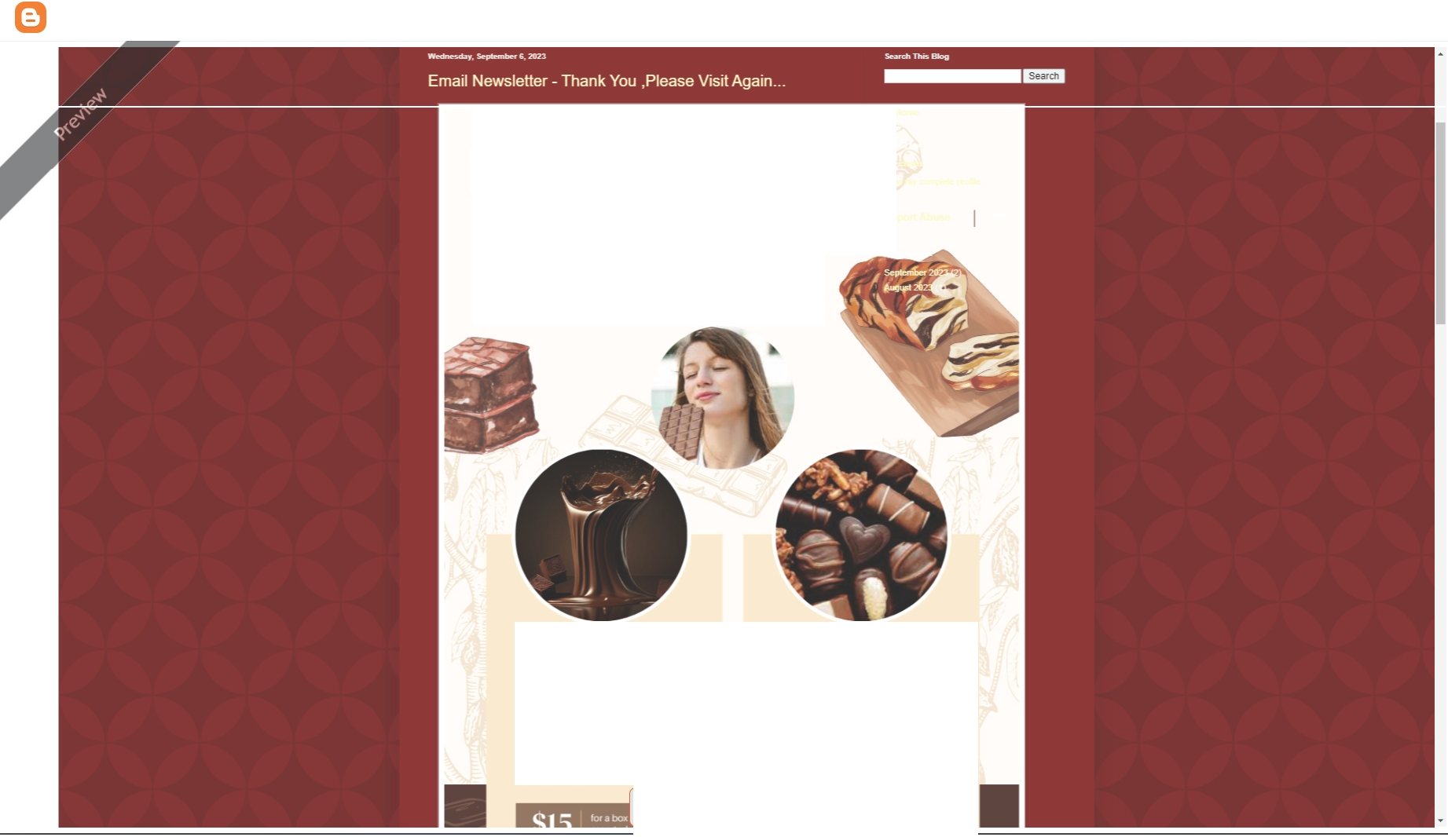

**Star \lhocs a**

-SWee'f **DUGS**

# "Your support is im aluablc.Thank you for choosing us!We're eager to \\ elcome ou back "ith open anns and exceptional

sen ice. Please come again soon!"

### **01** S\\ITZ OIOCOL\T[ **02** BLITZOIOCOL\T[

IndulgeInthe nch andcreamy Swttz **chocolate. k:nown for llssmooth texture** and exqu1S11e llawrs. Elll!I)'piece IS **carefullycrafted, ensuringf!Nery aspect** olmaking hlQ!HlU3litychooolale is

**giVenmeticutous anenuon Thts** guarantees a heavenly expenence for **your taste buds..**

Treat yourself 10the finest Blitz chocotale, renowned f011tsvelvety consis1ency and unoqueblend ol flavors. Made wilh high-quality cocoa beans. 1hesechocolatesotter a dellghlfutcombinallan of richnessand

subtlety.

o D D 0 c W

**Star \lhos**

**-5\\TeT D UGS**

**"Your support is invaluable. Thank you for choosing us! We're eager to \Velcome you back \Vith openarn1s and exceptional service. Please co111e again soon!"**

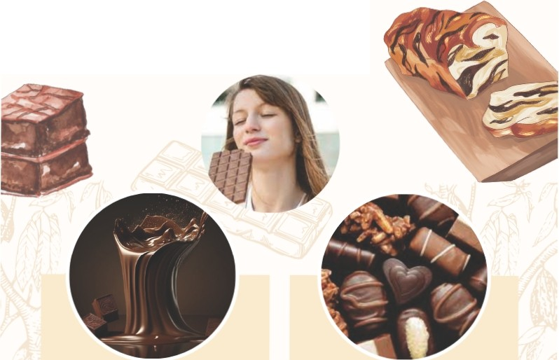

**01 S\\11Tl CHOCOLATE 02 BLITZ Cl IOCOLATE**

Indulge In the rich and creamy Switz choco ate, known for Itssmooth texture and exquisite navors.Every pieceis carefully crafted. ensuringevery aspect of making high-quality chocolate is givenmeticu ous attention.This guarantees a heavenly experience for your taste buds.

$15 I for a box of 12

## Treat yourself to the finest Blitz chocolate,renowned for its ve vety consistency and unique blend of

flavors.Made with high quality cocoa beans. thesechocolates offer a delightfulcombinationof richness and subtlety.

for abox of 16

assorted chocolates $18 1



pralines.